INVITATION
Academia Humana Foundation

Requests the pleasure of Your Company

at the re-unveiling ceremony of
Garden of Philosophy

a group of statues by Nándor Wagner (1922-1997) and presented to Budapest in 2001

at 11:00 o’clock on Thursday the 17th of June, 2010

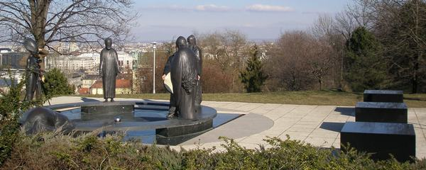

Location of the event:
Water Reservoir Park Gellérthegy, Sánc and Orom utca

Speakers:

dr. András Bőhm President of Cultural Committee of Municipality of Budapest

dr. Gábor Tamás Nagy Mayor of I. District

Ms. Chiyo Wagner the wife of the sculptor will attend

Organizer: Municipality of Budapest

Sándor Kiss László Szundy
President Curator
Map

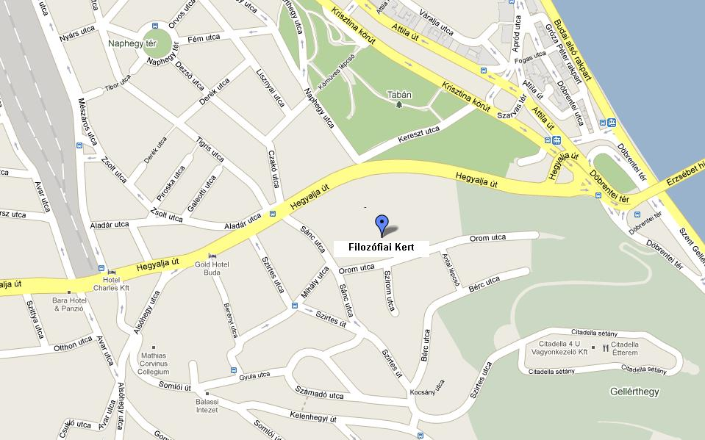

Bus: No. 8, 27 and 112 calls at Sánc utca stop
Car Parking free of charge in Orom utca

